**News Feature**

The news feature is a means by which the hospital will be able to display on the website, latest hospital news & articles of current or past events or activities taking place with or at the hospital.

**Narrative Description**

**End-User**

End-user means a website visitor to the homepage who can read news which uploads in the news section.

**Admin**

The news feature will have an administrative backend that will manage the news. On the administration backend side the user will be able to manage the form through insert, update and delete. An admin user can preview the news in the news section once it is uploaded. An admin user can edit a piece of news in the news section if they uploaded news is incorrect or needs the title or description changed. An admin user can delete news from the news section if they no longer need it

**Wireframe**

**End User –** Version 1.0.1

Read view

When the end-user logged in and go to the news section they will see this view of the news. There are three most recent news shown on the page. The first news is default expanded to display to beginning of the news story and a “Read full story” link below it. If the visitor clicks the any head of these three accordion boxes, that news will be expanded and others will be collapsed. And if the visitor clicks the “Read more” link it will jump to the news detail page to show the full story.

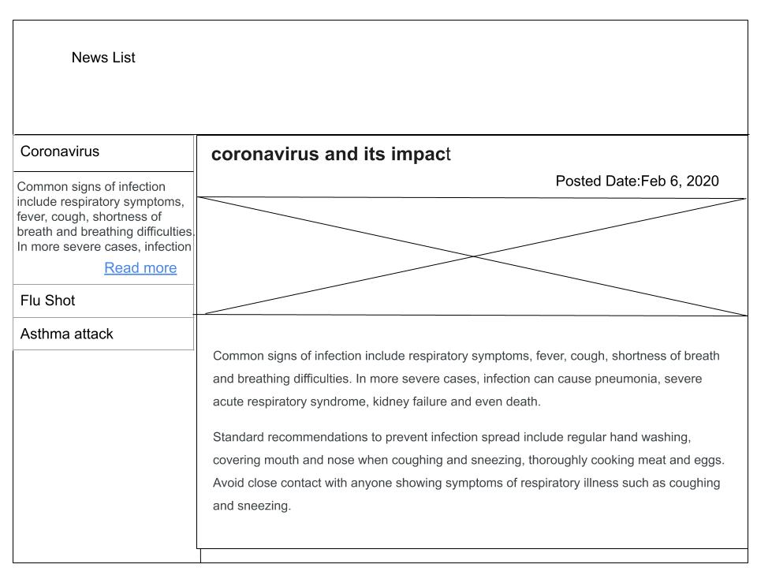

**Admin User -** Version 1.0.1

Create View

When an Admin wants to add a new news then they can click on “add news” button and

Logged in admin user has the authority to create news and upload it to the news section.

Admin can add the title of the news, upload image related news and write a description on it and in alt text admin can describe the image based on what and by clicking upload news button admin can upload the news in the news section. Data of uploaded new news’s will be store in the database.

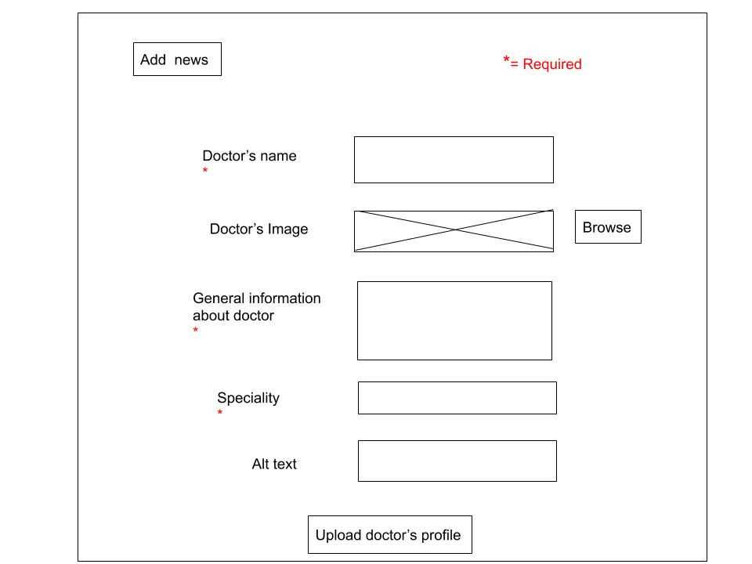

**Admin User -** Version 1.0.1

Read View

In the admin side, the admin can add/update/delete the news. While adding news, the administrator can choose an image to upload as the news image. If there is an image for the news, the visitor will see the news title, image and full story while reading the full story. If there is no image for the news, the visitor can only see news title and full story. And while editing news, the administrator can also choose a new image for the news or just delete the image for the news.

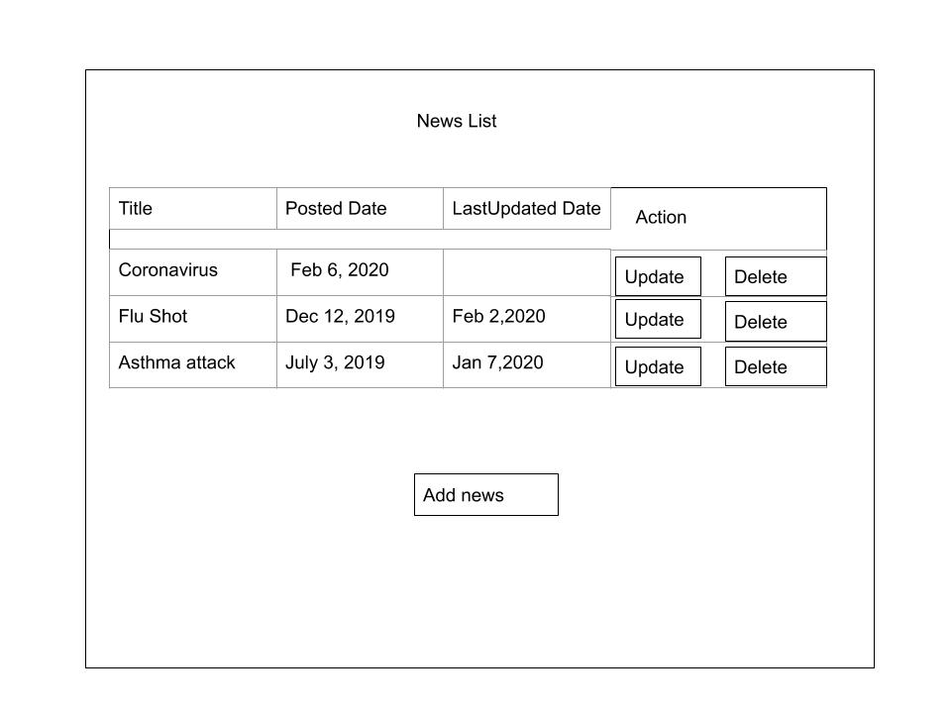

**Admin User -** Version 1.0.1

Update View

If admin wants to update some information in the news so, admin can do changes in that and by clicking the update news button they can upload the updated news in the news section.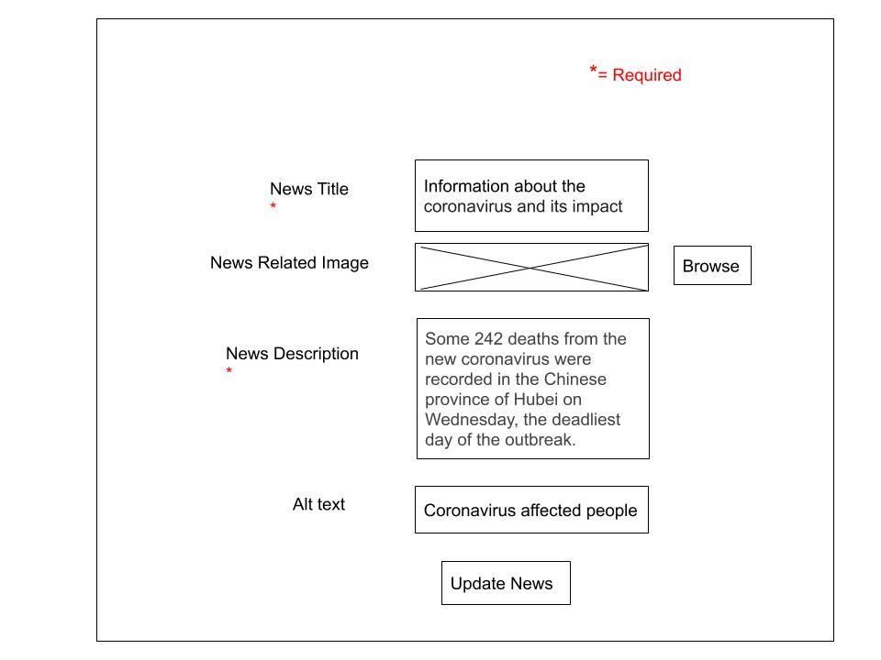**Admin User -** Version 1.0.1

Delete View

When Uploaded news gets older and there is no need of that news then admin deleted that news.

To delete the news admin has to click on “Delete” button when they click it they will get a warning of “Are you sure you want to delete this news?” to ensures that they surely wants to delete that news. When they click “yes” news gets deleted from the screen and database and if they changed their mind and don’t want to delete that they can click “no”. then nothing will be change.

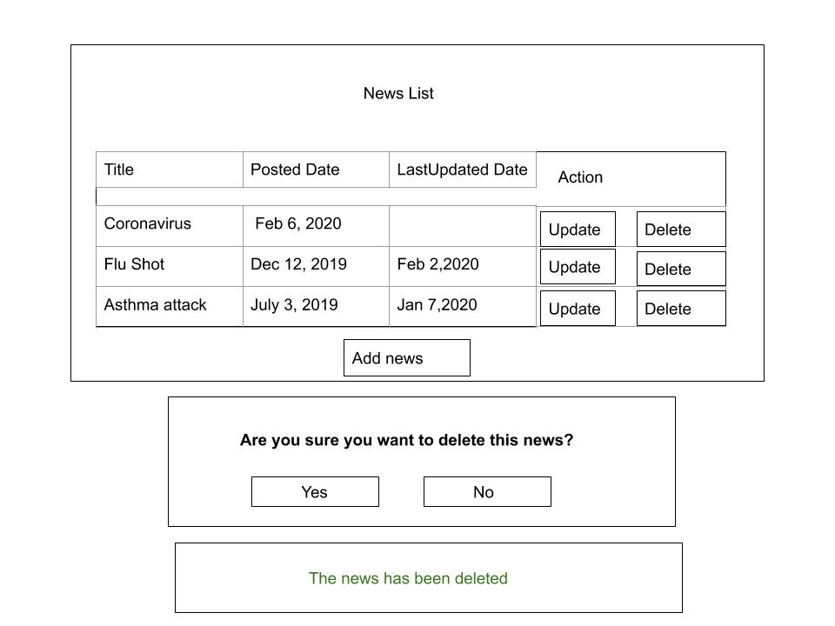

**Find A Doctor Feature**

Find a doctor is a feature, by using that patient can search a doctor by name or by their specialty. They should be logged-in, to see the link. A patient can also view full profile of a doctor including his/her email and phone number, from that profile there is a book an appointment link by using that patient can book an appointment with a doctor. This feature has admin view too. An admin can view all the doctor records, and also can add new doctors when they join the hospital. When information needs to be deleted or changed, admin can do that too.

**End-User**

End user is a website visitor and logged in user can find a doctor by using find a doctor feature.

**Admin**

A logged-in admin user will be able to add, preview, edit, and delete news in the news section

Once the admin user is logged in they can go to the find a doctor feature and add, preview, edit and delete the doctor in the find a doctor section.

A logged-in admin user can upload a doctor and provide a specialty of that doctor with a brief introduction.

A logged-in admin user can preview the doctor’s list in the find a doctor section once it is uploaded.

A logged-in admin user can edit doctors and their information in the find a doctor section if they uploaded information is incorrect or needs the description changed.

A logged-in admin user can delete doctor from the find a doctor section if they no longer available in that hospital.

**Wireframes**

**End User -** Version 1.0

When user(patient) wants to find a doctor so user has to first login if they enter all credentials correct then they can go to that page otherwise they will get an error message that “Please enter a valid credentials”. Once user gets logged in it will directly go to user’s home page and then they can click on find a doctor from the navbar and it will directs user to the find a doctor page in that user can search doctor by name and specialty and hit submit button. It will directly sent user to doctor’s detailed page.

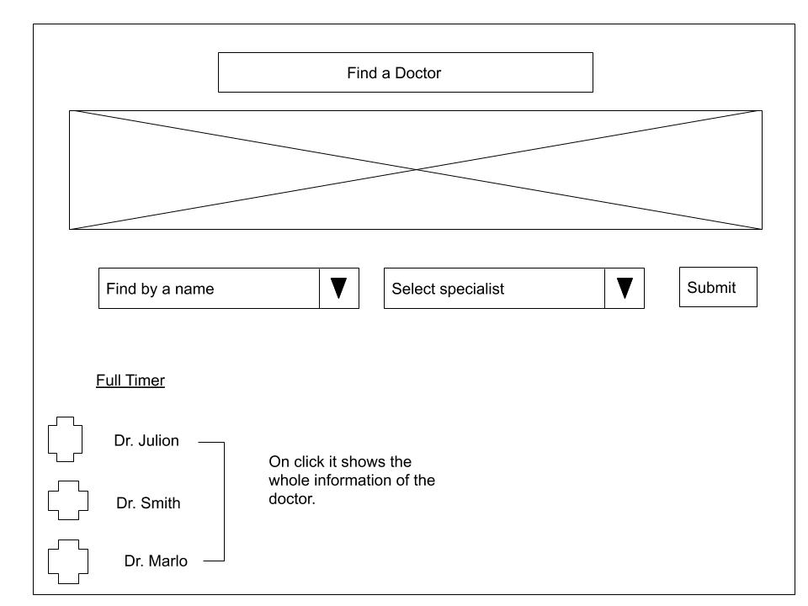

When user click on the doctor they will get this view which is showing below.

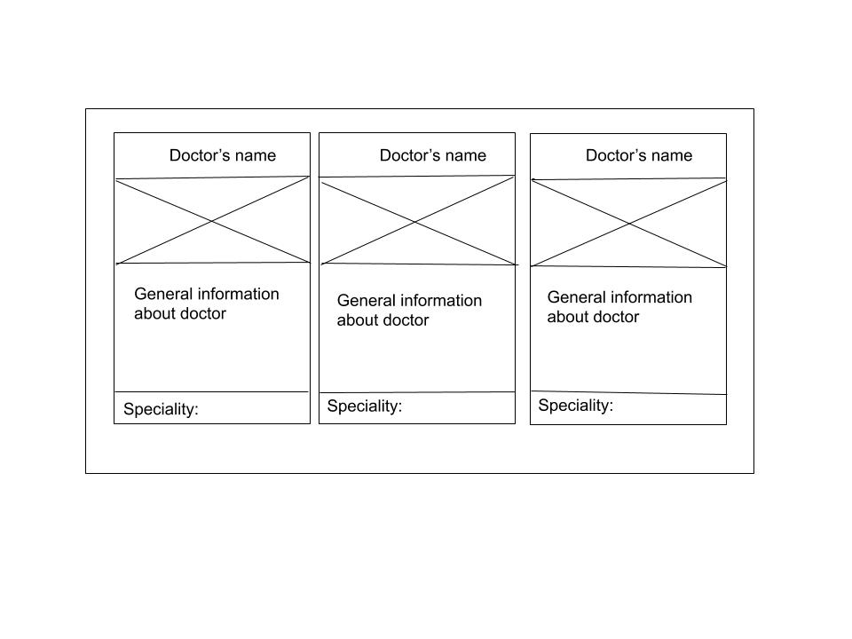**Admin User - Version 1.0**

Create View

When new doctor get hired in the hospital then admin can create that doctor’s profile. Admin will add doctor’s name,image,phone number and other general information. When admin clicks on “add” button new doctor’s information will be created on the find doctor page and in the database.

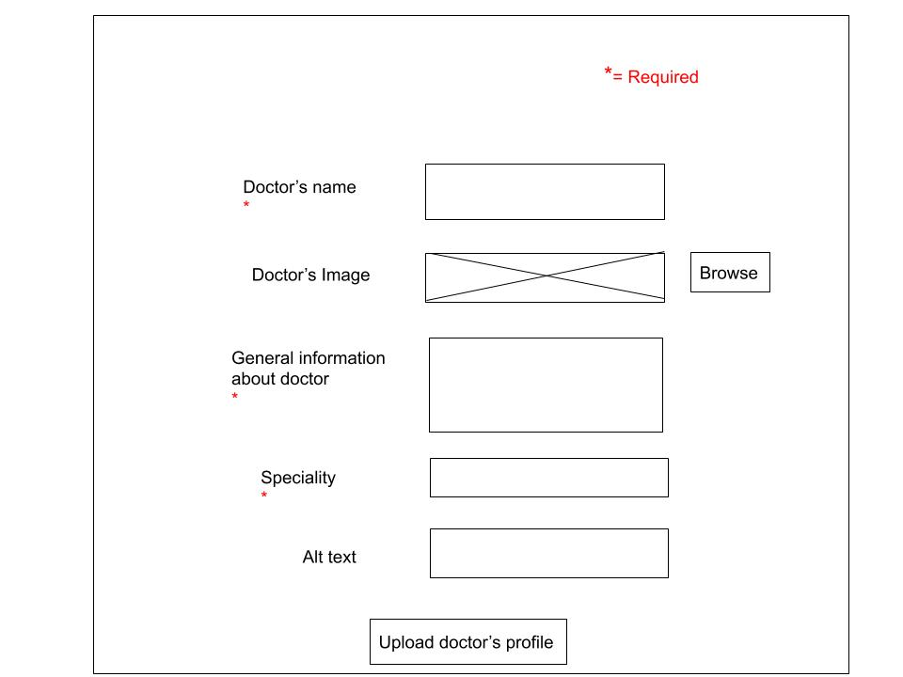

**Admin User - Version 1.0**

Read View

Admin also has read view of doctor. Admin also can check all the information of doctors and do add/update/delete.

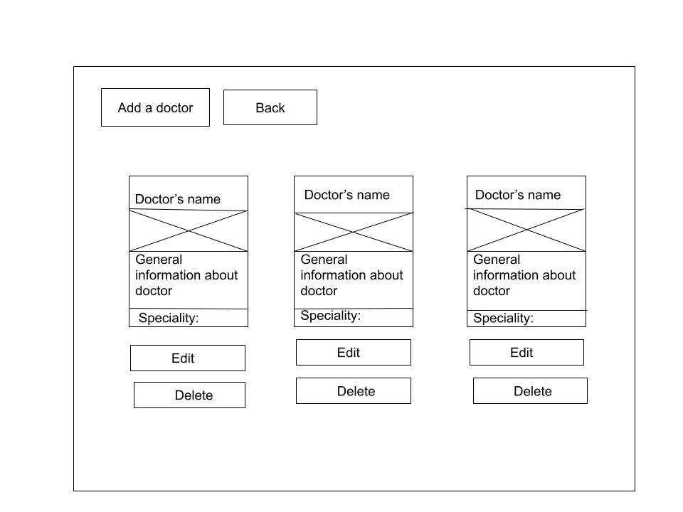

**Admin User**

**Version 1.0 - Update**

When doctor get promoted and be a part time or become specialist then admin has to update that doctor’s profile. Admin will update in doctor’s general information and other fields.In Image section if Admin want to upload new image then he has to press brows button.When admin clicks on “Update” button new doctor’s information will be updated in the find doctor page and in the database.

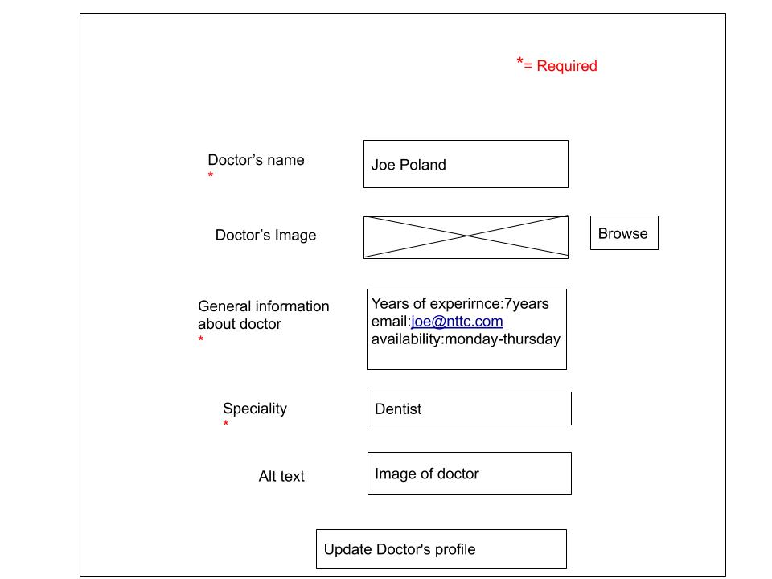

**Version 1.0 - Delete**

When doctor quite that hospital job or get retired then admin can delete their profile from the find a doctor page by clicking delete button. When admin clicks on the “delete” button They will get notify by a message like “are you sure want to delete?”. If admin press “no” then it will remain as it is and if admin press “yes” It will delete data from the page and database permanently.

